**Prof.V.B.Shah Institute of Management & R.V.Patel College of Commerce (Eng.Med.) &V.L.Shah College of Commerce (Guj.Med.) &**

**Sutex Bank College of Computer Applications & Science, Amroli**

**(Accredited ‘B’ (CGPA 2.55) by NAAC Dec.-2009)**

# VEER NARMAD SOUTH GUJARAT UNIVERSITY, SURAT



**PROJECT REPORT**

**ON**

### Employee Management System

**AS A PARTIAL REQUIREMENT FOR THE DEGREE**

**OF**

**BACHELOR OF COMPUTER APPLICATION**

**(B.C.A.)**

SUBMITTED BY: GUIDED BY:

Asst. Prof. Twinkle S. Panchal PATEL YASH(242)



**Certificate**

This is to certify that the project titled **Employee Management System** is the bonafide work carried out by  **Patel Yash(242),** student of TYBCA Sem-VI of Sutex Bank College of Computer Applications and Science, Amroli, (Surat) affiliated to Veer Narmad South Gujarat University. He/she has successfully completed his/her project work in partial fulfillment of the requirements for the award of the degree of **"Bachelor of Computer Application"** during the academic year **2022-23**. And that the project has not formed the basis for the award previously of any other degree, diploma, fellowship or any other similar title.

_______________________________ _______________________________

Asst. Prof. Twinkle S. Panchal  **Dr. Mukesh Goyani**

Project Guide Principal

**Date:**

**Place:** Amroli, Surat.

ACKNOWLEDGEMENT

|  |  |
| --- | --- |
| Chapter | PageNo |
| 1. **Introduction**    1. College Profile    2. Project Title    3. Project Profile |  |
| 1. **Environment Description**    1. Hardware and software Requirement    2. Technologies Used |  |
| 1. **System analysis and Planning**    1. Existing system and drawbacks    2. Feasibility Study    3. Requiremen Gathering and Analysis |  |
| 1. **Proposed System**    1. Scope    2. Project Modules    3. Expected Advantages |  |
| 1. **Detail Planning**    1. Data Flow Diagram / UML    2. Process Specification/ Activity Flow Diagram    3. Data Dictionary    4. Entity-Relationship Diaagram / Class Diagram |  |
| 1. **System Design**    1. Database Design    2. Directory Structure    3. Input Layouts |  |
| 1. **System Testing** |  |
| **8.Limitations and Future Scope of Enhancements**  **References** |  |

**1**

Chapter

**Introduction**

1.1 College Profile

1.2 Project Description

1.3 Project Profile

1.2 Project Description

* Employee management system is a type of management system, where manager can manage their subordinates in efficitive and efficitent way.
* In this system a manager can assign task easily to employee(s) in a convinient way.
* So that, manger can count which task is assigned to whom.
* Maintain attendence of employees in a convinient way.
* For example Check-in and Check-out of an employee is managed by system and refelcted to the employee side.

1.3 Project Profile

|  |  |
| --- | --- |
| Field | Description |
| Project Title : | Employee Management System |
| Description : |  |
| Front-End : | ReactJs |
| Back-End : | NodeJs , mongoDB |
| Technology : |  |
| Tools : | VScode |
| Internal Guide : | Asst. Prof. Twinkle S. Panchal |
| Submitted By : | Patel Yash N. |

**2**

Chapter

**Environment Description**

2.1 Hardware and software Requirement

2.2 Technologies Used

2.1 Hardware and Software Requirement

Hardware Requirement:

Technologies Used:

2.2 Technologies used

* Core Technologies
  + React JS
  + NodeJS
  + MongoDB
  + HTML
  + CSS3
  + AWS

**3**

Chapter

**System Analysis and Planning**

3.1 Existing System and Drawbacks

3.2 Feaisibility Study

3.3 Requirement Gathering and Analysis

3.1 Existing System and Drawbacks

* **ReactJS Front End**
  + ReactJS is frontend Javascript framework for building user interface.
    - React use declarative approach to define a component
    - React uses component base architecture. Each UI component can be reusable.
    - React uses Virtual DOM in order to optimise the rendering time.
    - React uses only one-way data flow. It means data pass form parent component to child component.
    - React is open source Javascript library.
    - React is cross platform framework.
    - It is easy to learn and runs efficiently on forntend side.

**Advantages of ReactJS:**

1. Server side rendering means it improve the application performance and SEO.
2. React can be use on IOS and Android devices and the name is React native.
3. Easy to test because UI is divided into smaller components and if a component have a bug a developer can easily spot it.
4. Large and active community of developer means there library , tools and tutorials are easily available.

* **NodeJs**
  + NodeJs is open source javascript runtime environment.
    - Nodejs is Ascychronous non-blocking programming.
    - Nodejs can be use for data intensive apps.
    - Nodejs is blind on V8 engine and V8 engine is use by Google chrome.
    - NodeJs use NPM for managing packages.
    - Nodejs is cross platform means it can run on any OS.
* **Advantages of ReactJS:**
  + NodeJS use Javascript for it`s backend coding so, a frontend developers have to use same programming language.
  + Nodejs have a wide range of packages , which provides wide range of functionality like database drivers.
* **MongoDB**
  + MongoDB is cross platform document based NoSQL database.
    - MongoDB is scalable high performance database .
    - MongoDB stores data in JSON like format.
    - Easy to store data and manage complex data types.
    - MongoDB have the ability to handle large amount of data through horizontal scaling.

* **Advantages of ReactJS:**
  + Because MongoDB is horizontally scalable an organization can add more server.
  + MongoDB have no constrains like SQL databases like Foreign Key.
  + Because, MongoDB is have less constraint base it is easy to manage data in database.
* **HTML5**
  + HTML 5 is the fifth version of HTML. It use to create web pages and application
    - HTML 5 allow user to enter date , time , email and search.
    - HTML 5 support video and audio playback.
    - HTML 5 allow to store webpage in offline mode.
    - HTML 5 ease the developer work on image resize.
    - HTML 5 introduce new tag name <picture> to adject the image resolution.

* **Advantages of HTML5:**
  + HTML 5 is compatable with modern browsers like Chrome, Safari, Firefox, and Internet explorer.
  + HTML 5 ease the work of developers by introducing new features.
  + HTML 5 support mobile devices and support touch base interface.
  + HTML 5 improve the lodaing of page by intorducing the new features like local storage.
* **CSS3**
  + CSS is used in frontend side of a web page. It describes the HTML elements how to behave when page loads.
    - CSS3 allow web pages to adapt different screen sizes.
    - CSS3 enable frontend developer to do animations and transations.
    - CSS3 allow developers to use custom fonts.
    - CSS3 introduce flex box layout that enable developers to align and distribute sapce in a container.
* **Advantages of CSS3:**
  + CSS3 allow to select specific tag for example child tags.
  + Media query allow an element to adjust according the screen size.
  + CSS3 introduce box-sizing property to change the default box model.
  + CSS3 support SVG , which can be scaled without loosing quality of an image.
  + CSS3 supports every browser.
* **AWS**
  + Amazon Web Service abbriviated as AWS managed by Amazon. It is cloud computing platform.
    - AWS provides a load balancing service that distribute incoming traffic.
    - AWS provides security to application like firewall.
    - AWS offers pay as you go pricing model.
    - AWS provides automation tools like AWS Lambda and AWS cloudFoundation.

* **Advantages of AWS:**
  + AWS ensres application and services always available.
  + AWS is distributed around the globe. So, it make easy to deploy application in distinct regions and provide low-latency.
  + AWS integrates other services like DevOps tools, databases, and analytical services.
  + AWS provides virtual machine services to run applications on that OS.

1. Technical Fesibility
2. Economy Fesibility
3. Operational Fesibility

3.2 Feasiblity Study

3.3 Requirement gathering and Analysis

* Manager assign the task to employees.
* Admin manges the subordinates.
* Maintain the employee attendence.
* Schedule the shift of employees.
* Manage the company details.
* Manage the department of each employee.
* Maintain the designation of employee.

**4**

Chapter

**Proposed system**

4.1 Scope

4.2 Project modeles

4.3 Expected advantages

4.1 Scope

* **Modules:**
  1. Admin
  2. Manager
  3. Team Member
  4. Team Incharge
* Admin
  + Manage subordinates
  + Manage task assigining
  + Manage

4.2 Project modules

4.3 Expected Advantages

**5**

Chapter

**Detail Planning**

5.1 Data Flow Diagram

5.2 Process Specification

5.3 Data Dictionary

5.4 Entity-Relationship Diagram

5.1 Data Flow Diagram

* 0Th Level DFD

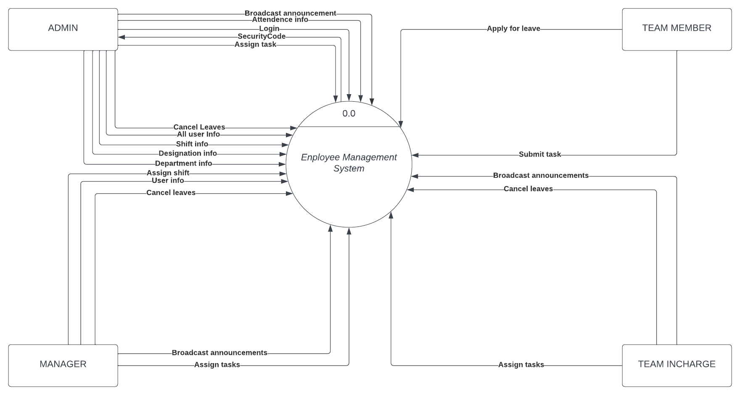

5.2 Process Specification

5.3 Data Dictionary

5.4 Class Diagram

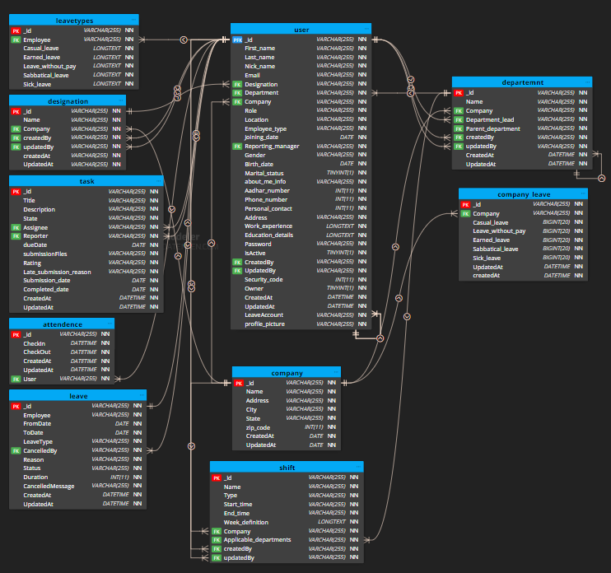

**6**

Chapter

**System Design**

6.1 Database Design

6.2 Directory Structure

6.3 Input Layers



6.1 Database Design

6.2 Directory Structure

6.3 Input Layouts

**7**

Chapter

**System Testing**

**8**

Chapter

**Limitations and Future Scope of Enhancements References**